**Hands on Exercise**

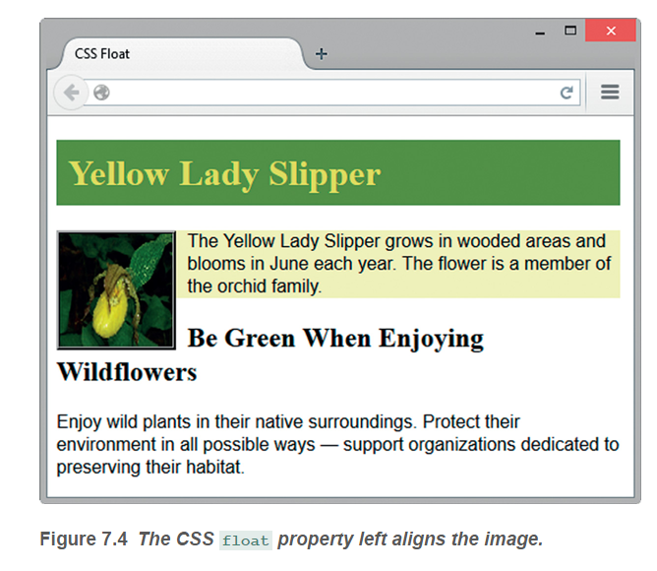

Create a folder named ch7float. Copy the starter2.html and yls.png files from the chapter7 folder in the student files into your ch7float folder. Launch a text editor and open the starter2.html file. Notice the order of the image and paragraphs. Notice that there is no CSS to float the image. Display starter2.html in a browser. The browser renders the page using normal flow and displays the elements in the order they are coded.

Let’s add CSS to float the image. Save the file with the name floatyls.html. With floatyls.html open in a text editor, modify the code as follows:

1. Add a style rule for a class named float that configures float, margin, and border properties:

.float { float: left;

margin-right: 10px;

border: 3px ridge #000000; }

1. Assign the image element to the class named float (use class="float").

Save the file. Launch a browser and test your page. It should look similar to the web page shown in [**Figure 7.4**](https://jigsaw.vitalsource.com/books/9780133971026/epub/OPS/xhtml/fileP7000495062000000000000000002023.xhtml#P7000495062000000000000000002052).